## 1. Efforts Estimation for RPA – Network Alarm Monitoring and Resolution:

|  |  |
| --- | --- |
| **Tasks** | **Client Name- Salvage Automation (Hours)** |
|
| Requirements Gathering | 12 |
| Design/Creation of Solution design document | 12 |
| Development | 120 |
| Testing | 40 |
| UAT & Production deployment | 12 |
| Hyper care/Support | 24 |
| **Total** | **220** |
| **Total Efforts** | **6 Weeks** |

**Project Schedule / Timelines**

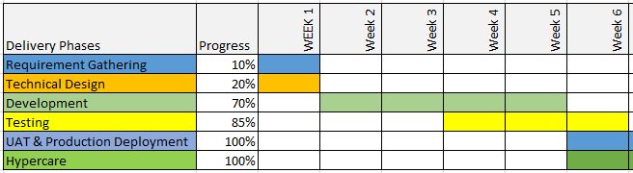

## 2. Efforts Estimation for RPA – Alarm received but not processed on NMS:

|  |  |
| --- | --- |
| **Tasks** | **Client Name- Salvage Automation (Hours)** |
|
| Requirements Gathering | 8 |
| Design/Creation of Solution design document | 8 |
| Development | 40 |
| Testing | 15 |
| UAT & Production deployment | 10 |
| Hyper care/Support | 24 |
| **Total** | **105** |
| **Total Efforts** | **3 Weeks** |

**Project Schedule / Timelines**

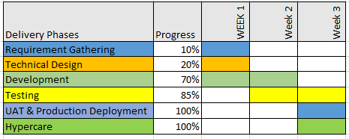

## 3. Efforts Estimation for RPA – Alarm received on Network Management System:

|  |  |
| --- | --- |
| **Tasks** | **Client Name- Salvage Automation (Hours)** |
|
| Requirements Gathering | 8 |
| Design/Creation of Solution design document | 8 |
| Development | 40 |
| Testing | 15 |
| UAT & Production deployment | 10 |
| Hyper care/Support | 24 |
| **Total** | **105** |
| **Total Efforts** | **3 Weeks** |

**Project Schedule / Timelines**



## 4. Efforts Estimation for RPA – Ticket Investigation and Resolution:

|  |  |
| --- | --- |
| **Tasks** | **Client Name- Salvage Automation (Hours)** |
|
| Requirements Gathering | 12 |
| Design/Creation of Solution design document | 12 |
| Development | 120 |
| Testing | 40 |
| UAT & Production deployment | 12 |
| Hyper care/Support | 24 |
| **Total** | **220** |
| **Total Efforts** | **6 Weeks** |

**Project Schedule / Timelines**



## 5. Efforts Estimation for RPA – Monitoring and Highlighting Exceptions:

|  |  |
| --- | --- |
| **Tasks** | **Client Name- Salvage Automation (Hours)** |
|
| Requirements Gathering | 8 |
| Design/Creation of Solution design document | 10 |
| Development | 60 |
| Testing | 26 |
| UAT & Production deployment | 12 |
| Hyper care/Support | 24 |
| **Total** | **140** |
| **Total Efforts** | **4 Weeks** |

**Project Schedule / Timelines**

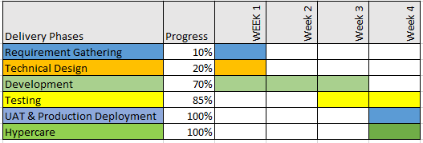

## 6. UIPATH Licensing Price Estimation:

